Soil Erosion and Its Impact on the Environment

Introduction: Soil erosion is considered when the top layer of soil gets washed by environmental elements and loses its production fertility. It is extremely harmful for the global environment. Now a days human beings are making so many constructions and using a lot of toxic elements that really damage the environment and soil. So, we should stop soil erosion immediately.
Importance of addressing soil erosion in our current world:
- As we know, soil stores carbon. It highly contributes greenhouse gas emissions. So that is why soil erosion must be stopped. Soil is a very important element in our environment. If the soil becomes polluted all the other animals will be demolished. Food security completely depends on soil. For this reason, we must plant more and more trees to remove soil erosion. Bennett (1928) mentioned that removing soil erosion is necessary for our ecosystem in rural and urban economies. For the betterment of our environment, we should take care of our soil. On the other hand, if the soil becomes unfertilized, the farmer cannot produce crops and vegetables on the field. That is why addressing soil erosion is very important in our current world.

Some major causes of soil erosion:
- Human activity: The major reason for soil erosion is human activity. Deforestation is mainly caused by human beings. Excessive construction decreases the volume of our land. That is why the progress of soil fertilization becomes demolished.
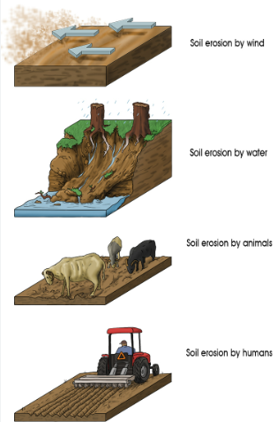
Click here
- Water pollution: Water is the second most important element for our environment. If water is polluted, the soil erosion starts increasing.

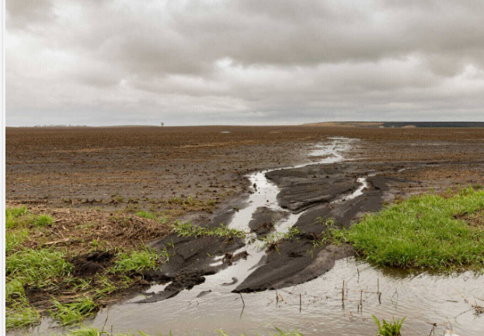
Click here
- Wind flow: Sometimes winds blow dry areas and dry soil away and thus soil erosion occurs.
- Climate change: Climate change is also a reason for causing soil erosion. In climate change sometimes the environment destroys the soil like more intense storms or prolonged droughts.
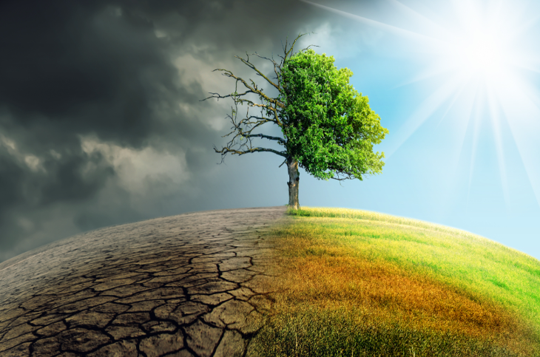
Click here
- Poor Land Management: Sometimes for over-cultivating crops, lack of crop rotation can degrade the soil fertilization.

Here are some major impacts of soil erosion.
- Impacts on Agriculture: Generally, agricultural productivity totally depends on soil fertility. Farmers can get good results if they do not produce the same crops again and again. Because repetitive crops production badly hampers soil productivity that impacts on agriculture. Harden (2001) mentioned that heavy soil erosion badly damages the productivity of vegetation. Sometimes farmers use more chemical fertilizers to compensate for lost nutrients that increases the soil erosion.
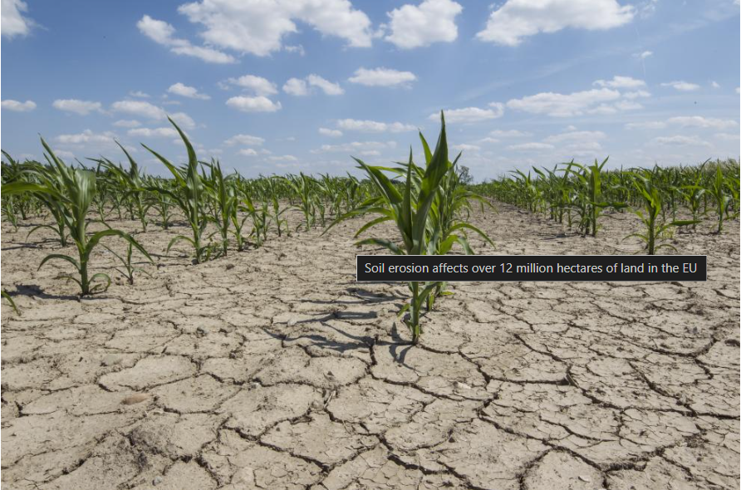
Click here
- Impacts on water quality: Sometimes the water is polluted from soil erosion. Soil erosion often carries pollutants and pesticides. That degrades water quality and impacts drinking water supplies.
- Impacts on Biodiversity: Erosion can destroy natural habitats, plants and animal species. If the soil structure reduces then the other organisms like insects’ worms and microbes will affect the global ecosystem.
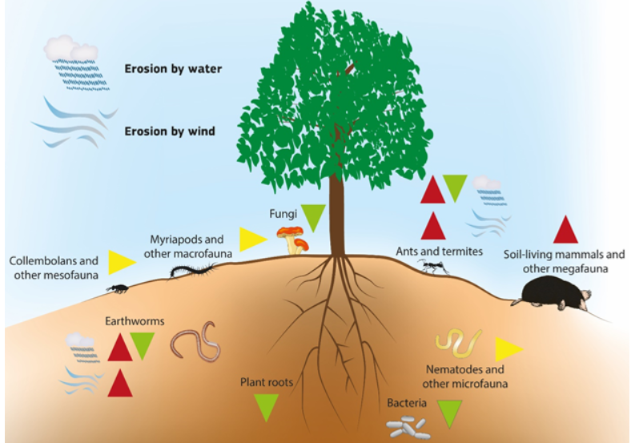
Click Here

- Soil erosion may cause respiratory issues and lead to health problems. It reduces crop yields, increases costs for farmers and leads to loss of income. It can cause cancer and another heart disease. If the soil is polluted, and trees, water and fish become toxic. It also hampers our economic productivity. If the soil is not fertilized, the farmers will not be able to produce crops and then the economic growth will be decreased so badly.

Sustainable practices to reduce soil erosion
- Planting cover crops: We must plant grasses or legumes between main crops to cover and protect the soil from erosion.
- Challenge: We need additional resources like seeds, pure water and worker but it’s difficult.
- Agroforestry: We must integrate trees and shrubs into farmland so that we can improve fertility.
- Challenge: We need time to mature trees and place to cultivate which require experienced workers and its time consuming.
- Conservation Tillage: We must reduce or eliminate tilling to maintain soil structure and minimize disruption.
- Challenge: We need new equipment or a change in farming practices to reduce and eliminate tilling.

Conclusion: Soil erosion happens when the top layer of soil is removed by natural forces like water and wind. Human activities and climate change heavy rainfall are the main causes for soil erosion. The impact of soil erosion is huge. Day by day, its impact is hampering our social and global environment. It’s damaging our soil fertility, loss of arable land, economic loss, water pollution and habitat destruction. It is also damaging agricultural productivity, poses a risk to human health. To address this challenge a range of sustainable practices like planting cover crops, agroforestry and conservation tillage are essential. These practices face challenges such as costs and climate unpredictability. In my opinion, we should plant more and more trees and produce crops based on the environment situation.
Recommendations:
- We should try to adopt sustainable farming practices.
- We should highly promote afforestation and reforestation.
- We must enhance community education and awareness about the disadvantages of soil erosion.
By following these recommendations, we can work towards reducing soil erosion.

References:
- Bennett, H. H. (1928). The Geographical Relation of Soil Erosion to Land Productivity. Geographical Review, 18(4), 579-605. https://www.jstor.org/stable/207949

- Harden, C.P. (2001). Soil Erosion and Sustainable Mountain Development: Experiments, Observations, and Recommendations from the Ecuadorian Andes. Mountain Research and Development, 21(1), 77-83. https://www.jstor.org/stable/3674135

